School of Computer Science and Artificial Intelligence

Lab Assignment # 2

Name of Student : GINNE SAI TEJA
Enrollment No. : 2303A51526
Batch No. : 22

Task 1: Cleaning Sensor Data
❖ Scenario:You are cleaning IoT sensor data where negative values are invalid.
❖ Task:Use Gemini in Colab to generate a function that filters out all negative
numbers from a list.
❖ Expected Output:
➢ Before/after list
➢ Screenshot of Colab execution

Prompt:
Create a Python function filter_non_negative that filters out negative values from a list and returns a new list without changing the original data.
Code:-
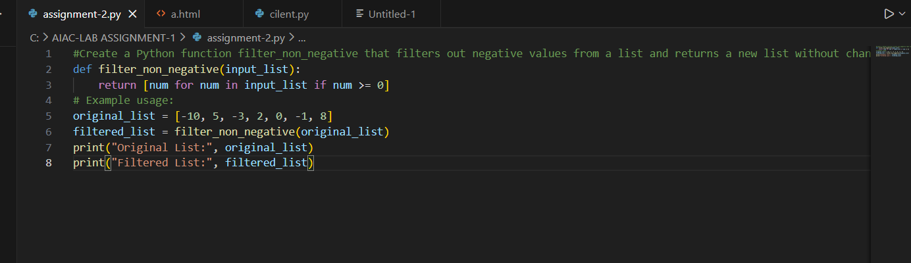

Output:-
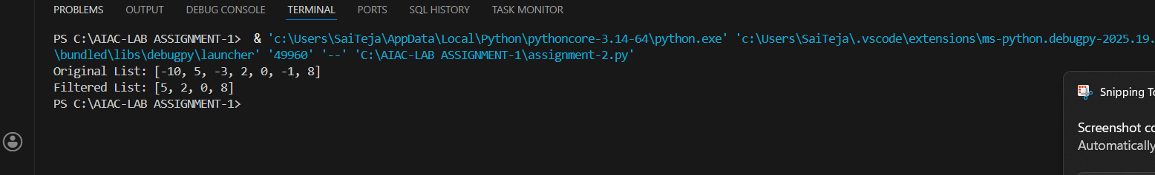

Justification:-
This function uses a list comprehension to generate a new list containing only non-negative values from the original list. It does not modify the original list, ensuring that the raw sensor data remains intact for further analysis or processing.

Task 2: String Character Analysis
❖ Scenario:
You are building a text-analysis feature.
❖ Task:
Use Gemini to generate a Python function that counts vowels, consonants,
and digits in a string.
❖ Expected Output:
➢ Working function
➢ Sample inputs and outputs

Prompt:-
Create a Python function that counts vowels, consonants, and digits in a string, ignoring letter case.
Code:-
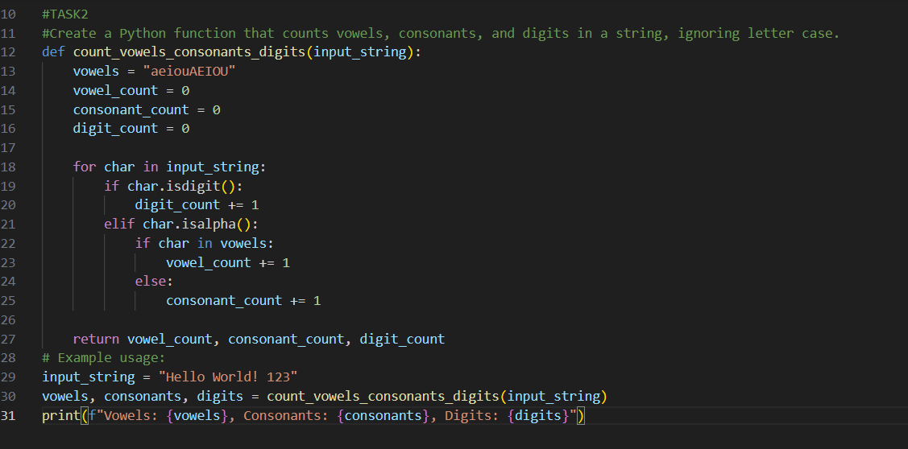

Output:-
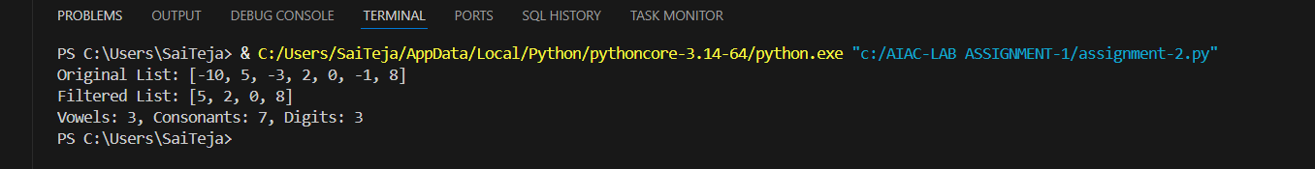

Justification:- This function iterates through each character in the input string and checks whether it is a vowel, consonant, or digit, incrementing the corresponding counters accordingly. It treats uppercase and lowercase letters the same by converting characters to a common case and using isalpha() to identify consonants accurately.
Task 3: Palindrome Check – Tool Comparison
❖ Scenario:
You must decide which AI tool is clearer for string logic.
❖ Task:
Generate a palindrome-checking function using Gemini and Copilot, then
compare the results.
❖ Expected Output:
➢ Side-by-side code comparison
➢ Observations on clarity and structure

Prompt:-
Create a Python function is_palindrome that checks whether a string is a palindrome, ignoring case and spaces.
.

Code:-
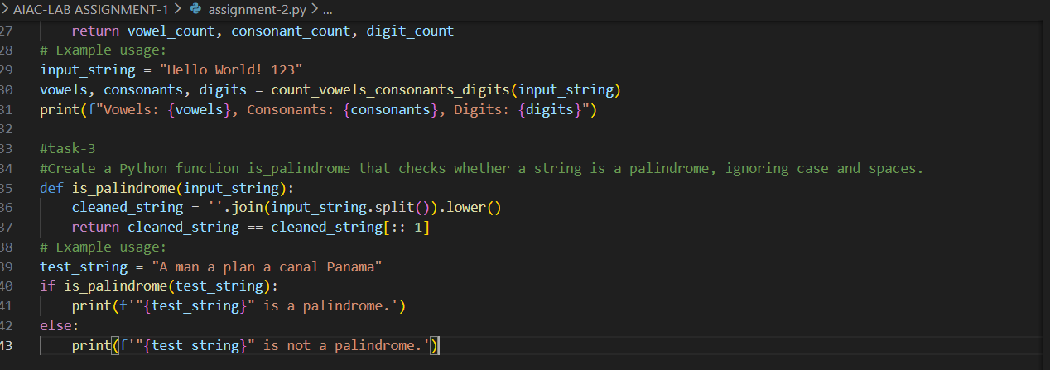

Output:-
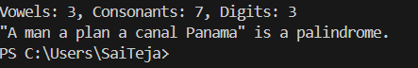

Justification:-
This function is simple and readable because it breaks the problem into clear steps. First, it cleans the string by removing non-alphanumeric characters and converting it to lowercase. Then, it checks whether the cleaned string is equal to its reverse. This step-by-step approach makes it easy for beginners to understand how palindrome checking works.

Task 4: Code Explanation Using AI
❖ Scenario:
You are reviewing unfamiliar code written by another developer.
❖ Task:
Ask Gemini to explain a Python function (prime check OR palindrome
check) line by line.
❖ Expected Output:
➢ Code snippet
➢ AI explanation
➢ Student comments on understanding

Prompt:-
Create a Python function (prime checker or palindrome checker) and explain each line in an easy way for beginners to understand.
Code:-
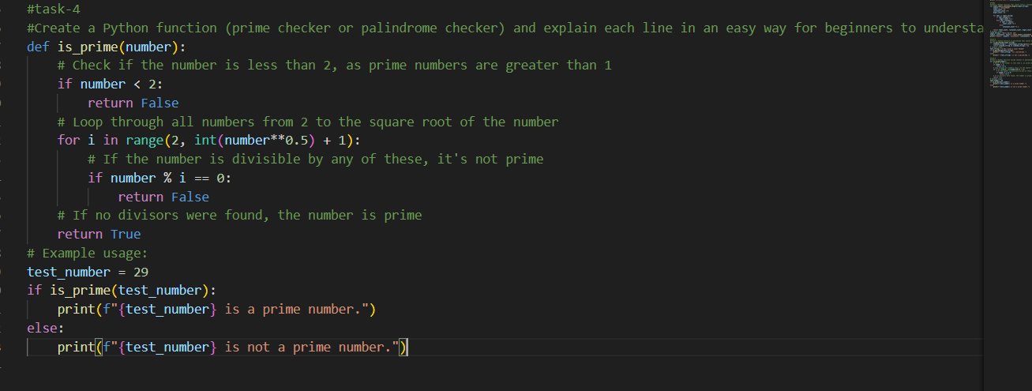

Output:-
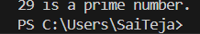

Justification:-
The function determines whether a number is prime by first checking numbers less than 2, since they are not considered prime. It then loops from 2 up to the square root of the number to check if the number is divisible by any of these values. If a divisor is found, the function returns False; if no divisors are found, it returns True, confirming that the number is prime.

